MATHEMATICS APPLICATIONS

MAWA Semester 2 (Units 3 & 4)
Examination 2018

Calculator-Assumed

Marking Key

© MAWA, 2018
Licence Agreement
This examination is Copyright but may be freely used within the school that purchases this licence.
- The items that are contained in this examination are to be used solely in the school for which they are purchased.
- They are not to be shared in any manner with a school which has not purchased their own licence.
- The items and the solutions/marking keys are to be kept confidentially and not copied or made available to anyone who is not a teacher at the school. Teachers may give feedback to students in the form of showing them how the work is marked but students are not to retain a copy of the paper or marking guide until the agreed release date stipulated in the purchasing agreement/licence.

The release date for this exam and marking scheme is
- the end of week 1 of term 4, 2018

Section Two: Calculator-assumed (100 Marks)

Question 7 (a)
Solution

6.25% of 16000 = 1000
Marking key/mathematical behaviours | Marks
- determines 6.25% of 16000 | 1

Question 7 (b)
Solution

P_{n+1} = P_{n} x 1.0625 – 1000, P₁ = 16000
Marking key/mathematical behaviours | Marks
- expresses relationship in correct format with first term  - identifies correct ratio | 1  1

Question 7 (c)
Solution
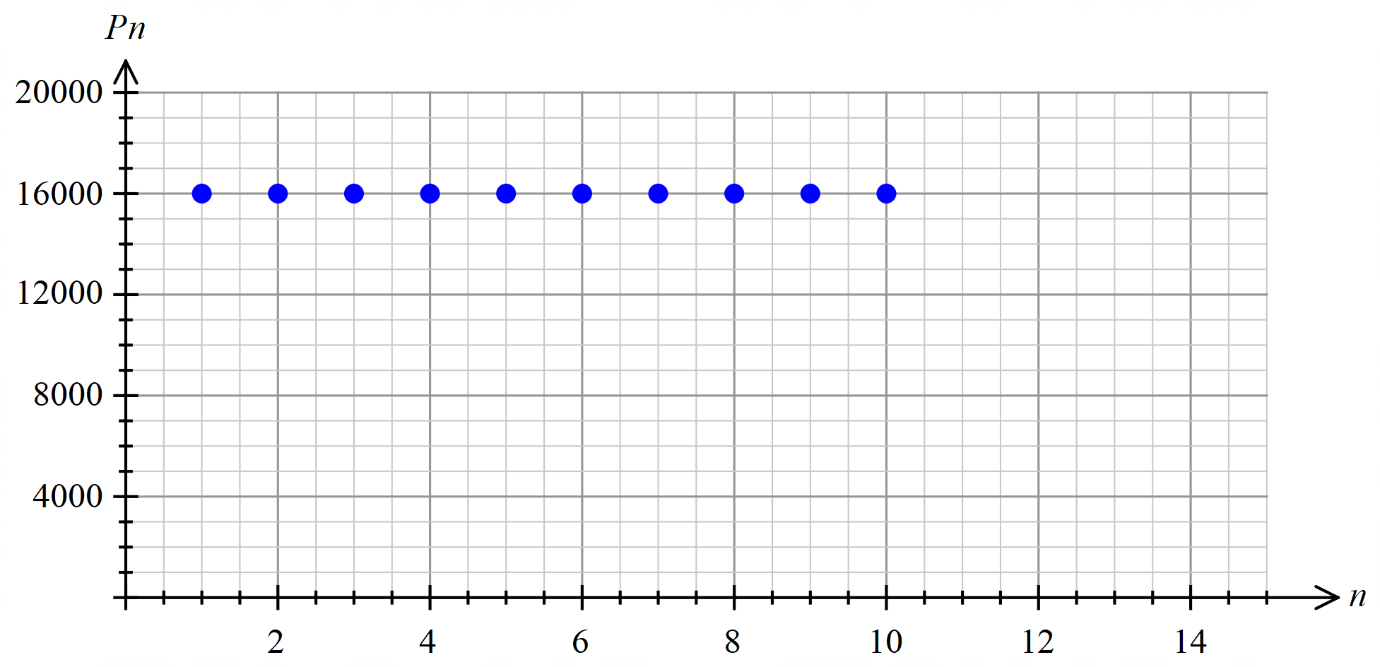

Marking key/mathematical behaviours | Marks
- labels and scales vertical axis  - labels and scales horizontal axis  - plots points | 1  1  1

Question 8 (a)
Solution

4-point cycle.
Values at quarter = 2,6,10,14 and 18 are quite high compared to the other values.
Marking key/mathematical behaviours | Marks
- identifies a 4-point cycle  - refers to the graph to justify conclusion | 1  1

Question 8 (b)
Solution

Downward trend.
Peaks and troughs are getting lower
Marking key/mathematical behaviours | Marks
- describes trend  - justifies trend | 1  1

Question 8 (c)
Solution

Summer 2021
Marking key/mathematical behaviours | Marks
- identifies season associated with occurrence | 1

Question 8 (d)
Solution

369 ÷ ((369+249+261+298) ÷ 4) x 100
Marking key/mathematical behaviours | Marks
- identifies the expression to calculate percentage of seasonal mean | 1

Question 8 (e)
Solution

(89 + 80 + 70 + 81) ÷ 4 = 80%
Marking key/mathematical behaviours | Marks
- determines seasonal index | 1

Question 8 (f)
Solution

207 ÷ 0.8 = 259
Marking key/mathematical behaviours | Marks
- determines deseasonalised data | 1

Question 9 (a)
Solution

BDFG 900
BMDFG 100
BMFG 200
BMPG 900
BMJPG 300
BMJG 800

Total number of cyclists is 3200
Marking key/mathematical behaviours | Marks
- determines 2 paths and their respective number of cyclists  - determines a further 2 paths and their respective number of cyclists  - determines a further 2 paths and their respective number of cyclists  - determines maximum number of cyclists | 1  1  1  1

Question 9 (b)
Solution

The maximum flow will not be affected so stays at 3200. The edge was not used in determining the path.
Marking key/mathematical behaviours | Marks
- describes the effect on the path  - justifies conclusion | 1  1

Question 10 (a)
Solution

n | 1 | 2 | 3
Value of boat after n years | $15 980 | $15 021.20 | $14 119.93

Marking key/mathematical behaviours | Marks
- determines two values  - determines third value | 1  1

Question 10 (b)
Solution

6% per annum
Marking key/mathematical behaviours | Marks
- identifies rate of depreciating | 1

Question 10 (c)
Solution

$1 020
Marking key/mathematical behaviours | Marks
- identifies the depreciated amount | 1

Question 10 (d)
Solution

Each year the rate is applied to a decreasing amount and thus the rate can be constant but the value is not.
Marking key/mathematical behaviours | Marks
- explains difference in rate and absolute change | 1

Question 10 (e)
Solution

Sell at 7000 or less. After 15 years.
(n = 15 6720 in value)
Marking key/mathematical behaviours | Marks
- determines sell-off value  - determines time for sell-off. | 1  1

Question 11 (a)
Solution

AMRWSC 31 days
Marking key/mathematical behaviours | Marks
- identifies critical path  - determines minimum completion time | 1  1

Question 11 (b)
Solution

EST = 22 days
LST = 23 days
Float time = 1 day
Marking key/mathematical behaviours | Marks
- identifies earliest start time  - identifies latest start time  - identifies float time | 1  1  1

Question 11 (c)
Solution

(i) The critical path changes to AMPKC and completion time increases by 2 days
(ii) The critical path is now 37 days and remains the same path
Marking key/mathematical behaviours | Marks
- (i) identifies path  - (i) identifies change to completion time  - (ii) identifies path  - (ii) identifies change to completion time | 1  1  1  1

Question 11 (d)
Solution

Activity | Immediate Predecessors | Time (days)
A | - | 5
B | A | 8
E | B | 7
F | A | 7
M | A | 6
R | M | 7
P | M | 8
W | F, R | 7
S | E, W | 2
T | F, R | 4
K | T, P | 4
C | S, K | 4

Marking key/mathematical behaviours | Marks
- lists all activities  - lists associated times taken  - identifies activities with single predecessors  - identifies activities with multiple predecessors | 1  1  1  1

Question 12 (a)
Solution

Strong association, points are close to each other on the graph
Direction is positive (upward), as cost increases, points are further up.
Marking key/mathematical behaviours | Marks
- identifies strength of the association  - justifies conclusion about the strength using graph’s features  - identifies direction of the association  - justifies conclusion about the direction using graph’s features | 1  1  1  1

Question 12 (b)
Solution

y=14.328 x – 840.25
Marking key/mathematical behaviours | Marks
- determines equation for least squares line | 1

Question 12 (c)
Solution

r = 0.8263
Marking key/mathematical behaviours | Marks
- determines the correlation coefficient | 1

Question 12 (d)
Solution

H = 13 x 90 –640 = $530 000
Marking key/mathematical behaviours | Marks
- substitutes into given equation  - determines median house price | 1  1

Question 12 (e)
Solution

The prediction is from within the given data ie interpolated
Correlation coefficient near 1 thus indicating a strong relationship
Marking key/mathematical behaviours | Marks
- gives one reason to justify reliability of prediction  - gives second reason to justify reliability of prediction | 1  1

Question 12 (f)
Solution

81%
Marking key/mathematical behaviours | Marks
- identifies coefficient of determination | 1

Question 12 (g)
Solution

$130 000
Marking key/mathematical behaviours | Marks
- interprets gradient of linear model | 1

Question 13 (a)
Solution

0.7%
Marking key/mathematical behaviours | Marks
- identifies monthly interest rate | 1

Question 13 (b)
Solution

T₁ = 25000 T _{n + 1} = T _{n} x 1.007 - 250
Marking key/mathematical behaviours | Marks
- rule is in the correct format  - correct ratio and subtraction | 1  1

Question 13 (c)
Solution

24 773.42, $173.41, $250, $24 696.83
Marking key/mathematical behaviours | Marks
- enters each data value into 4th row of the table | 4

Question 13 (d)
Solution

250 x 60 = $15000 paid in instalments. Loan reduced by 25000 – 19431.40 = $5568.40
Interest = 15000 - $5568.40 = $9341.40
Marking key/mathematical behaviours | Marks
- determines amount by which loan is reduced  - determines interest paid | 1  1

Question 13 (e)
Solution

No. Interest is still calculated once each month so the loan will not reduce any more quickly.
Marking key/mathematical behaviours | Marks
- concludes correctly  - justifies conclusion | 1  1

Question 13 (f)
Solution

Another 87 months (total 147 months). Altogether he takes 12 years and 3 months
Marking key/mathematical behaviours | Marks
- determines n=87  - interprets 87 in terms of the question | 1  1

Question 14 (a)
Solution

(0.5x265+323+288+213+238+307+0.5x360) ÷ 6 = 280.25
Marking key/mathematical behaviours | Marks
- identifies 7 values to use in the expression  - determines 6-point moving average | 1  1

Question 14 (b)
Solution

The data show a cycle of length 6 with a peak every 6 points and a trough every 6 points
Marking key/mathematical behaviours | Marks
- explains the cycle length of 6 | 1

Question 14 (c)(d)
Solution

Marking key/mathematical behaviours | Marks
- plots remaining points  - plots trend line for relevant account numbers  - uses appropriate slope for the trend line  - uses relevant vertical “intercept” for trend line | 1  1  1  1

Question 14 (e)
Solution

July 2018
Marking key/mathematical behaviours | Marks
- identifies year and month | 1

Question 14 (f)
Solution

Account 1
Marking key/mathematical behaviours | Marks
- identifies outlier | 1

Question 14 (g)(i)
Solution

36x25+68=968
968 x 27% = 261 L per day
Marking key/mathematical behaviours | Marks
- determines deseasonalised value for account 25  - selects correct seasonal index  - determines predicted daily water usage | 1  1  1

Question 14 (g)(ii)
Solution

Not reliable as the prediction is extrapolated and the linear model was determined from averaged cyclic data
Marking key/mathematical behaviours | Marks
- identifies predictability  - justifies conclusion | 1  1

Question 15 (a)
Solution

The higher the mean score the more likely it is that there is a high percentage of students reaching the highest level. OR The more students there are in the highest level, the greater the mean score is likely to be.
Marking key/mathematical behaviours | Marks
- justifies an association between the two variables | 1

Question 15 (b)
Solution

3
Marking key/mathematical behaviours | Marks
- distinguishes relevant data in table | 1

Question 15 (c)
Solution
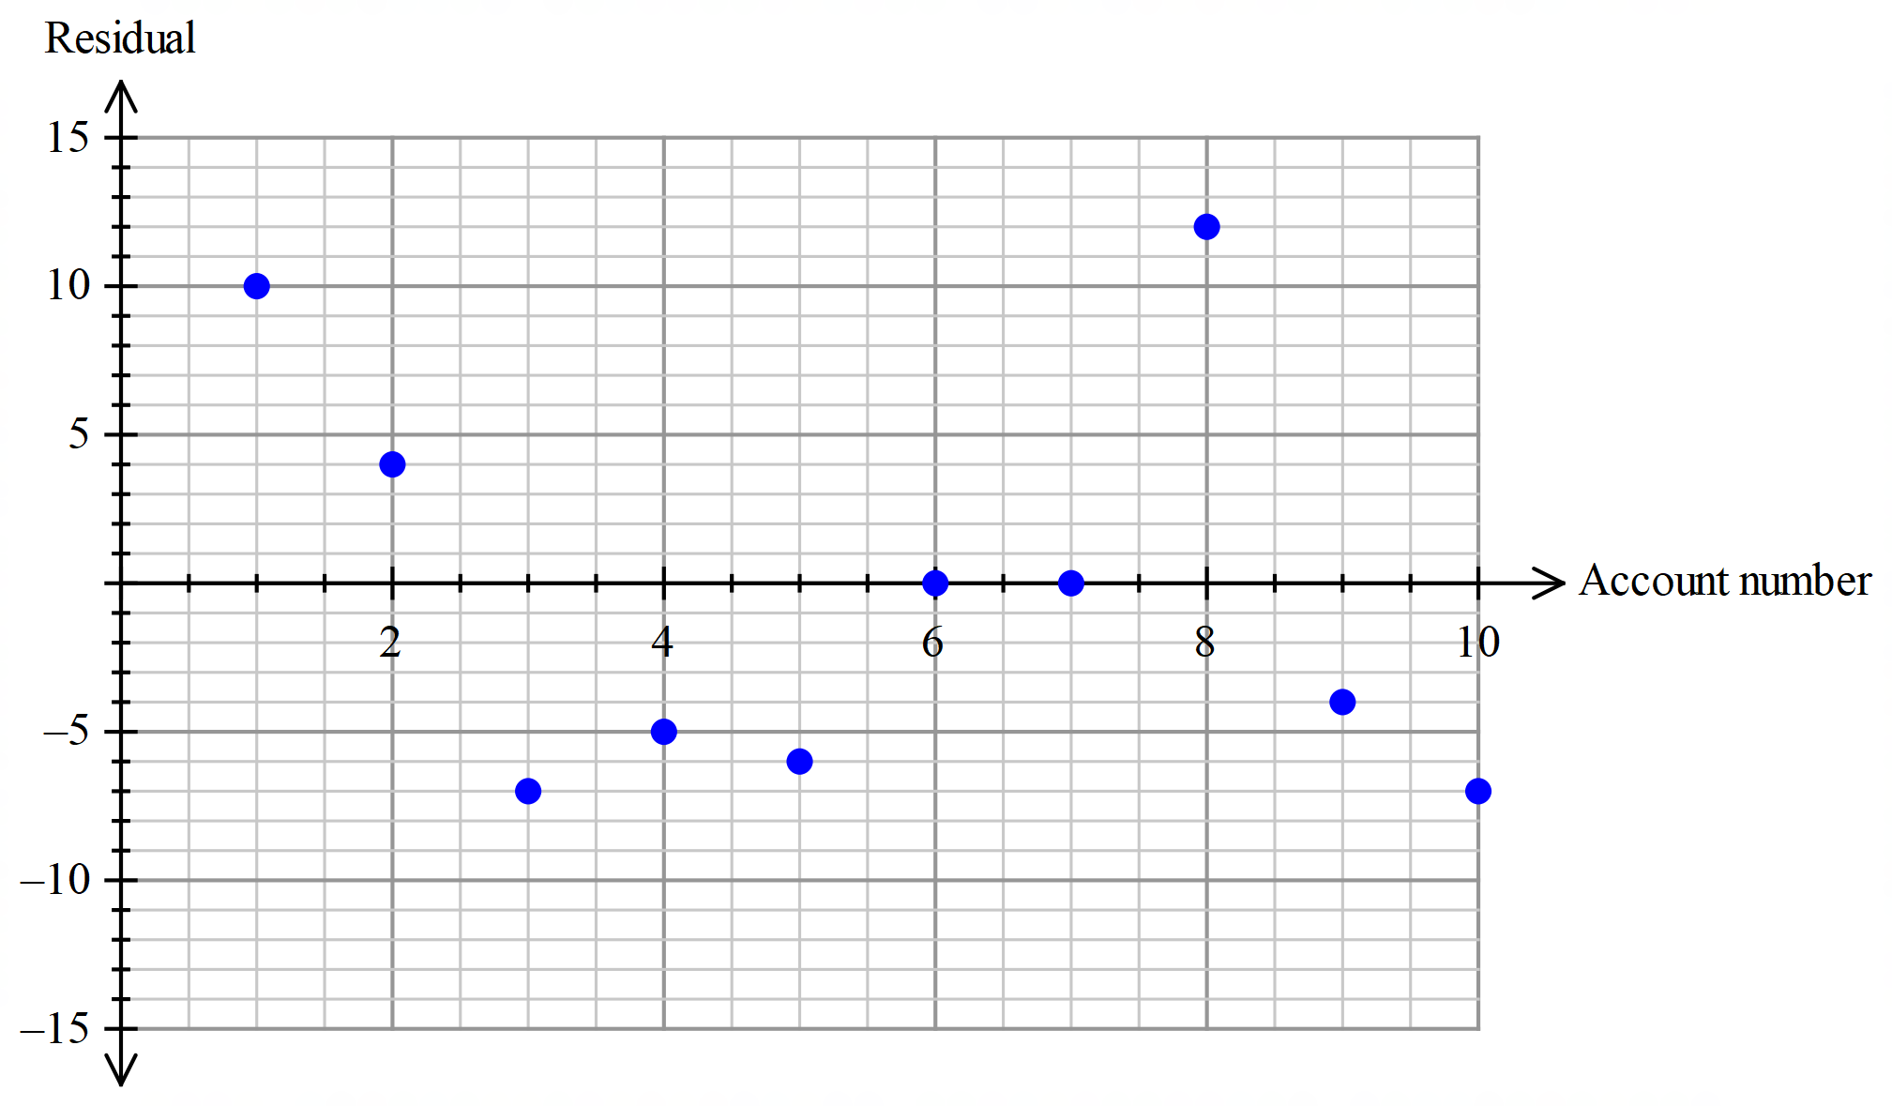

Marking key/mathematical behaviours | Marks
- labels and scales horizontal axis  - labels and scales vertical axis  - calculates residuals using observed - predicted  - plots 6 points correctly  - plots further 4 points correctly | 1  1  1  1  1

Question 15 (d)
Solution

A linear model is appropriate as there does not appear to be a pattern in the location of the points on the residual plot.
Marking key/mathematical behaviours | Marks
- concludes the linear model is appropriate  - justifies conclusion using residual plot | 1  1

Question 15 (e)
Solution

Even though the correlation between the two variables is high (r > 0.9) predications made from the linear model may not be reliable. The graph showing achievement looks exponential in nature and the data is only given for 10 countries. For one country the predicted percentage was negative, and this is not possible
Marking key/mathematical behaviours | Marks
- identifies reliability of the linear model  - justifies conclusion | 1  1

Question 16 (a)
Solution

v = 8, f = 7, e= 13 and v + f – 2 = e ie 8 + 7 – 2 = 13
Marking key/mathematical behaviours | Marks
- identifies the number of faces, edges and vertices  - verifies Euler’s rule applies | 3  1

Question 16 (b)
Solution

It starts and ends at the same vertex.
There are no repeated edges or vertices.
Marking key/mathematical behaviours | Marks
- identifies start and end points  - identifies each edge and vertex used once (except start) | 1  1

Question 16 (c)
Solution

OTBAKBSKPSTPWO
Marking key/mathematical behaviours | Marks
- identifies a route that contains no repeated edges  - includes all vertices | 1  1

Question 16 (d)
Solution

It has a closed trail which starts and ends at the same vertex and for which no edges are repeated.
Marking key/mathematical behaviours | Marks
- identifies edges are not repeated  - identifies starting and finishing at the same vertex | 1  1

